Module Name: Login Page - Functional & UI Test Cases
Test Case ID: st_01
Webpage URL: https://www.eatsure.com/

Step1 : Open login page
Step2 :Enter Username or mobile no
Step3 : Enter password or OTP
Step4 : Click Login
Step5 : Verify Login Page
Step 2 : Enter Username or mobile no
Step 3 : Enter password or OTP
Step 1 : Open Login Page
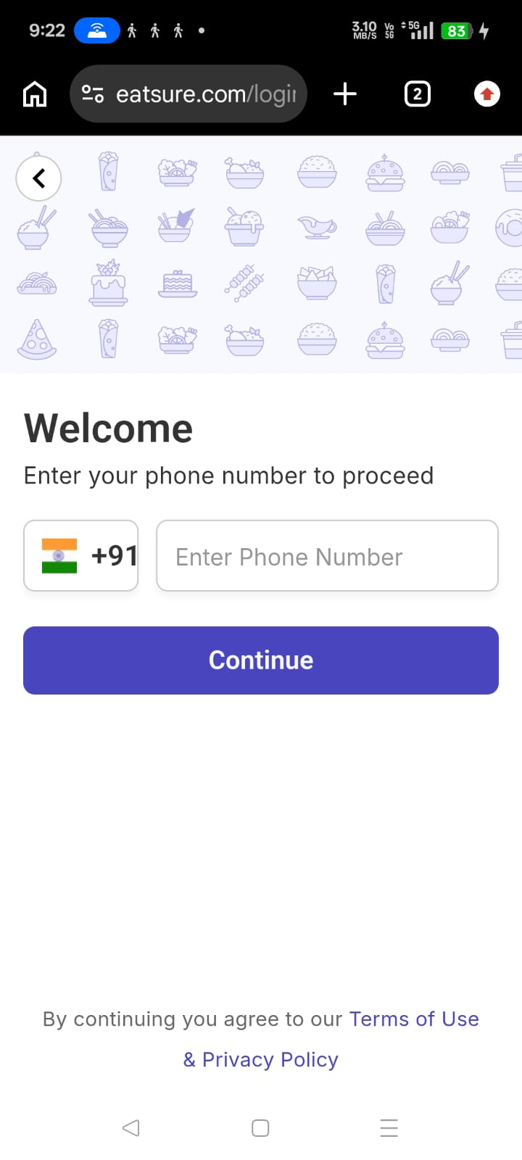
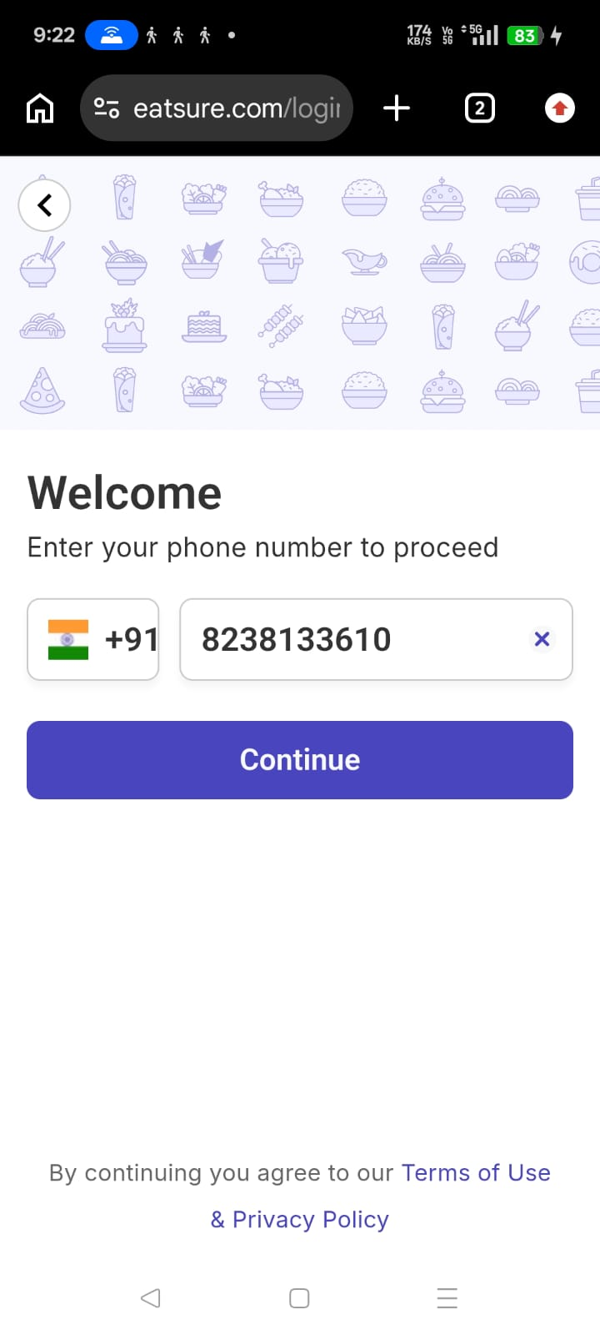
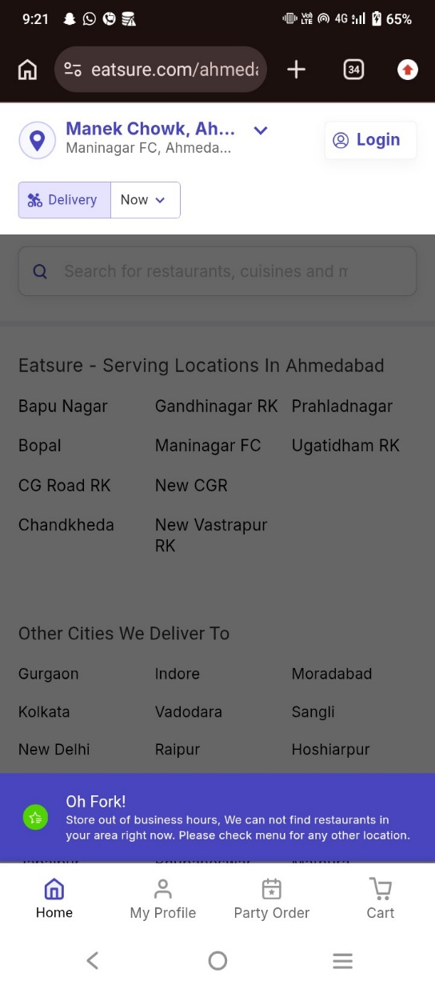

Step 5 : Verify Login Page

Step 4 : Click Login
